6.1

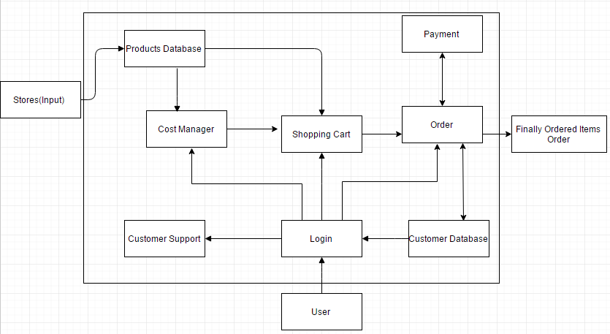

6.2



This system/block will have all the stores in a selected geographical area initially and then spread all over the country as the product is used by several users.



This system/block consists of all the stores’ product details which include product name, product id, quantity and other technical details of products. Shopping by a user or searching of different products from the cost manager done by the algorithm.



This system/block takes a list of products from the user as input. The list of items will be chosen economically from the locality by user the user’s location taken during the login process. The items will be searched from the Products Database and then added into the cart



Customer Support is a system which can be used once the user logins to his account he can interact with the customer service agents.



Shopping Cart is a block which can is used to input all the products and their quantities. This block will also carry all the necessary data of the products which is carted to be bought. This block will let us update the quantities of the item carted or to add or delete a product from the cart. This block will help is checkout process too.



The Login block will serve as a normal login interface which asks the user to enter his user name and password. This block will also provide the user to create an account, if he is using this application for the first time. This block will also detect the current location of the user.



This block represent the user, who is using the application.

v

Payment block is represents the payment gateway through which a user is allowed to make payments using various modes like credit card, debit card, Paypal etc.



This is the most important block which takes the shipping information from the customer database (if there is no shipping address in the customer database, then it asks the user to input here), has all the details regarding the products about their prices, quantities, and delivery dates. The user can login into his account and check all of his current and past orders in this system.



This system/block consists of user information like customer name, customer address, shipping addresses, phone number, emailed, credit card information. This block will also have his wish list item too.



Finally Ordered Items (order) is the output of the system which contains the order item details and their quantities and shipping details which is emailed to the user for his reference.

6.3

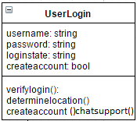

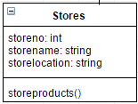

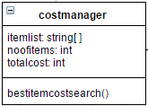

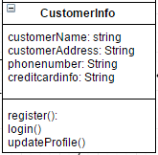

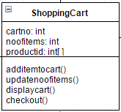

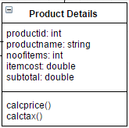

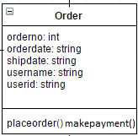

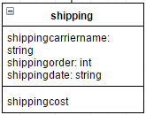

6.4

